Knights of Columbus

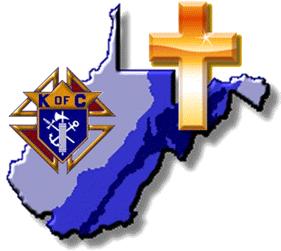
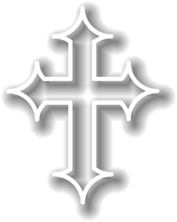
West Virginia State Council
Mid-Year Meeting

Dates: December 2, 2017
Location: St Brendan’s Catholic Church
Rt. 250 S Elkins WV, 26241
State Deputy: Scott K Nale

Agenda
Time | Topic
8:30-9:00 | Knight’s Mass
9:00-9:30 | Coffee and Doughnuts
9:30-9:35 | Call to Order, Opening Prayer and Pledge of Allegiance
9:35-9:45 | Roll Call
9:45-9:55 | State Deputy Welcome and Report from Supreme Meeting
9:55-10:10 | State Chaplain Comments – Fr. John
10:10-10:45 | Membership Review and Goals – Mike Sarkopski
10:45-11:00 | Break
11:00-11:50 | Membership thru Benefits – Mike Burkett
11:50-12:00 | Office of Youth Protection Compliance - State Advocates
12:00-1:00 | Lunch (Grace)
1:00-2:00 | Building the Domestic Church – Mike McDougal
2:00-2:15 | Comments from Supreme Representative
2:15-2:20 | New Council Development and Council Reactivation
2:20-2:25 | Star Council Status
2:25-2:30 | State Treasurer Summary Report
2:30-2:35 | State Warden Comments (Seminarian Support Program)
2:35-2:50 | Awards Presentation
2:50-3:10 | Outreach to Middle Eastern  Christians - Father Justin Blanc
3:10-3:20 | State Deputy Closing Remarks (Future of State Council – Motivational)
3:20 | Adjournment and Closing Prayer

