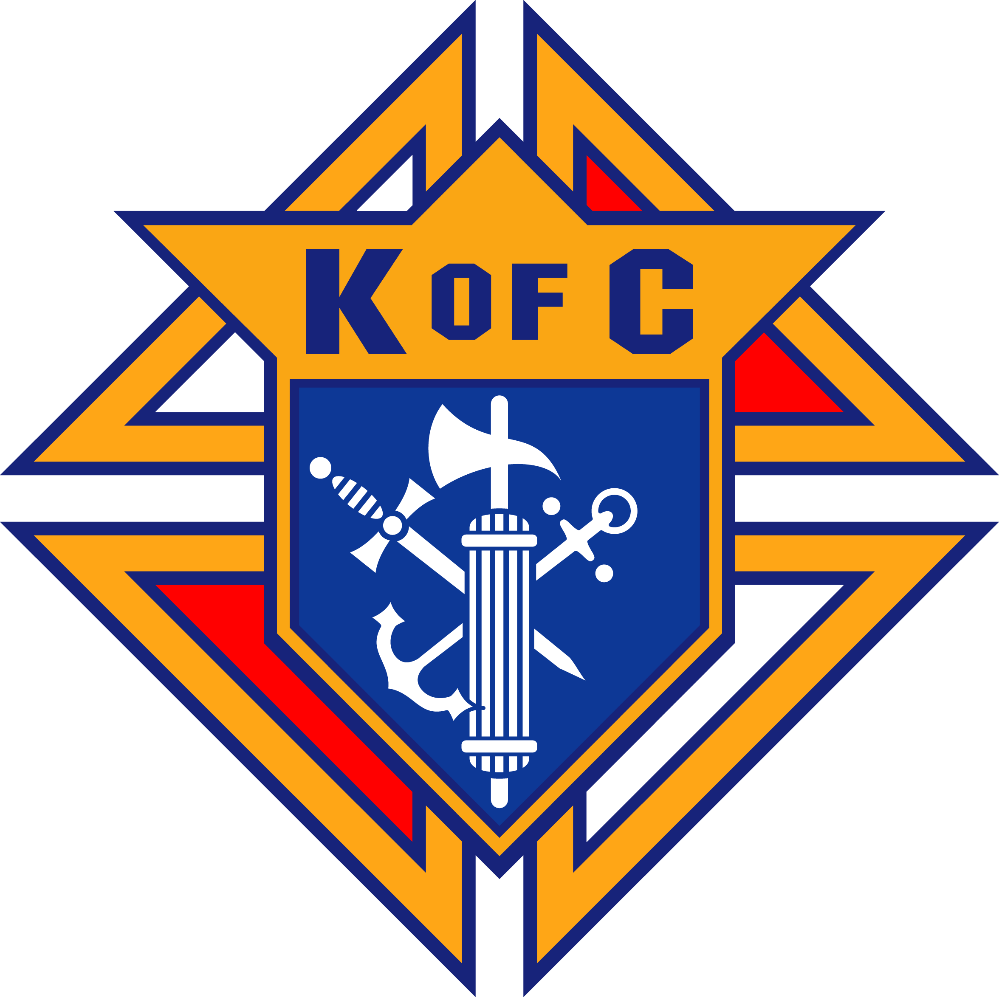
Knights of Columbus West Virginia Knights of Columbus Scholarship Foundation

Eligibility Rules & Information for
Knights of Columbus Wheeling Jesuit University Scholarship

1. To be eligible for a Knight of Columbus Wheeling Jesuit University Scholarship, you must
submit the following documents;

a) A letter from the University that you are enrolled or have been accepted for
admission.
b) A letter from the Council of which your father or immediate family member is a
member in good standing.
c) A transcript of your grade point average (GPA)
d) A Free Application for Federal Student Aid (FAFSA) and a list of Wheeling Jesuit
University Federal School code 003831. Forms are available at the Financial Aid Office at Wheeling Jesuit University or from your high school counselor.
e) Knights of Columbus Wheeling Jesuit University Scholarship form.
f) A copy of the applicant's Federal Income Tax return or the applicant's parent's return.
g) An autobiographical statement, including the following topics:
1. Church Activities.
2. School & Community Activities.
3. Goals & Objects.
4. Financial Needs.

2. The above documents can be submitted to the University Financial Aid Office or directly to the
West Virginia Knights of Columbus Scholarship Foundation, Inc. at:

WV K of C Scholarship Foundation, Inc.
Attn: Anthony J. Paletta
2687 Benedum Dr,
Bridgeport, WV 26330-7199

If you have any questions or need additional information, please contact me at:
(304)842-9200 or E-mail anthonypaletta71@gmail.com . The deadline for submitting the
applications is July 15.

