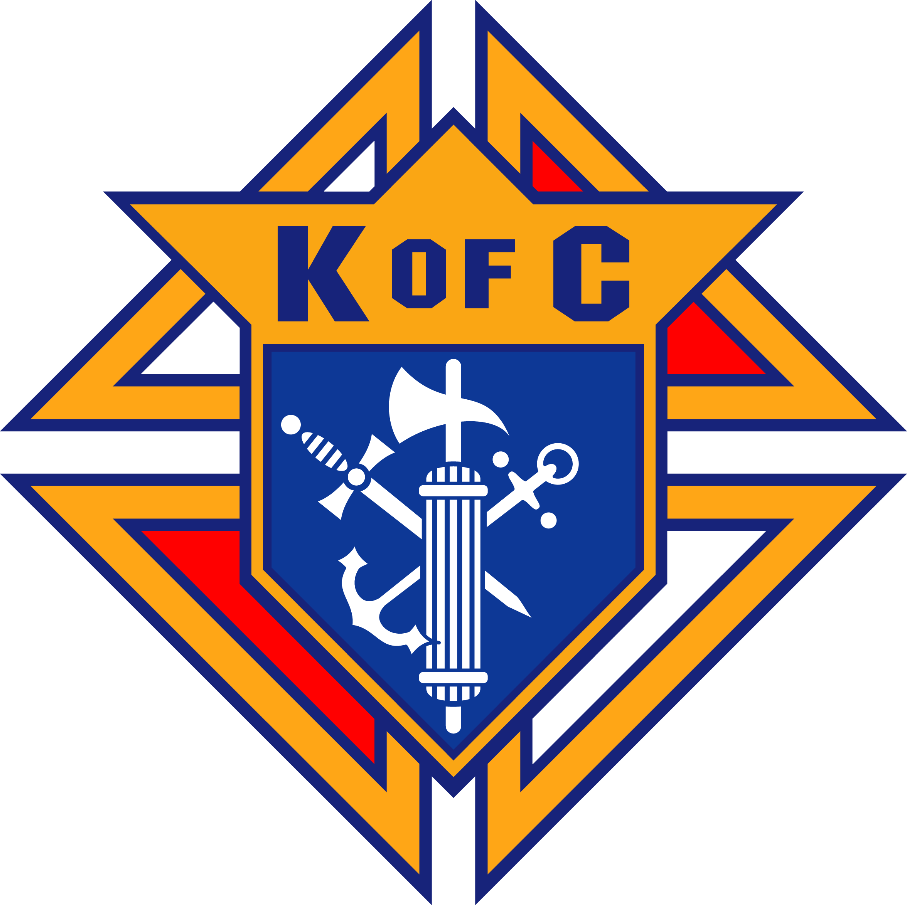
Knights of Columbus West Virginia Knights of Columbus Scholarship Foundation

Knights of Columbus Wheeling Jesuit University Scholarship Application
(This for is to be completed By the Applicant Only)

Name: _________________________________________________ _______ Date: ____/____/____
(Last, First, MI, Suffix)
Home Address: ________________________________________________________________________
Telephone: __________________________ E-mail: __________________________________________
Father's Name: ________________________________________________________________________
Council Name and Number: ______________________________________________________________
Place of Employment: ___________________________________________________________________
_____________________________________________________________________________________
Mother's Name: _______________________________________________________________________
Place of Employment: ___________________________________________________________________
_____________________________________________________________________________________
Siblings: Name Age
_____________________________________ __________________
_____________________________________ __________________
_____________________________________ __________________
_____________________________________ __________________
Name of Parish: _______________________________________________________________________
Pastor's Name and Address: ______________________________________________________________
_____________________________________________________________________________________
When do you plan to enter WJU? _________________ Tuition & Other Costs? ____________________
How do you plan to pay the tuition and other costs? __________________________________________
Applicant's Signature: ___________________________________________________________________
In order to be considered, return application by the due date stated in the instruction document.

